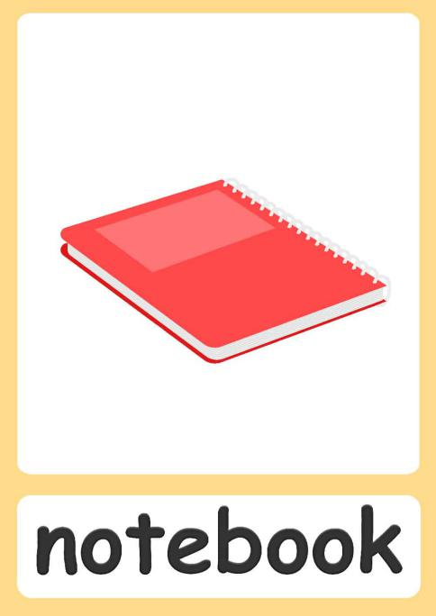 | pencil case
A notebook is a book or stack of paper pages that are often ruled and used for purposes such as :  - Take notes from your learning.  - Use it as a planner.  - Use it for drawing or scrap-booking. | A pencil case or pencil box is a container used to store pencils. A pencil case can also contain a variety of other stationery such as :  - pen  - Sharpener  - Scissors  - Eraser  - Glue stick  - Highlighter

