DEAR MRS KONSTANTINA

Since then the school closed because of CORONAVIRUS my life changed. I don’t go to ballet , I don’t meet with my friends and stay home all the day. My dad he doesn’t go to his work and he works from home. I spend time at home by reading an amazing book , watching TV, playing basketball , football and board games with my sister. I have drawn paintings and I have made constructions . Every noon I help my mum in cooking. I love cooking. In the afternoon I ride a bike in road which is outside my house. I am bored at home but I don’t want the school start .

I wish it is over soon!!!!!!

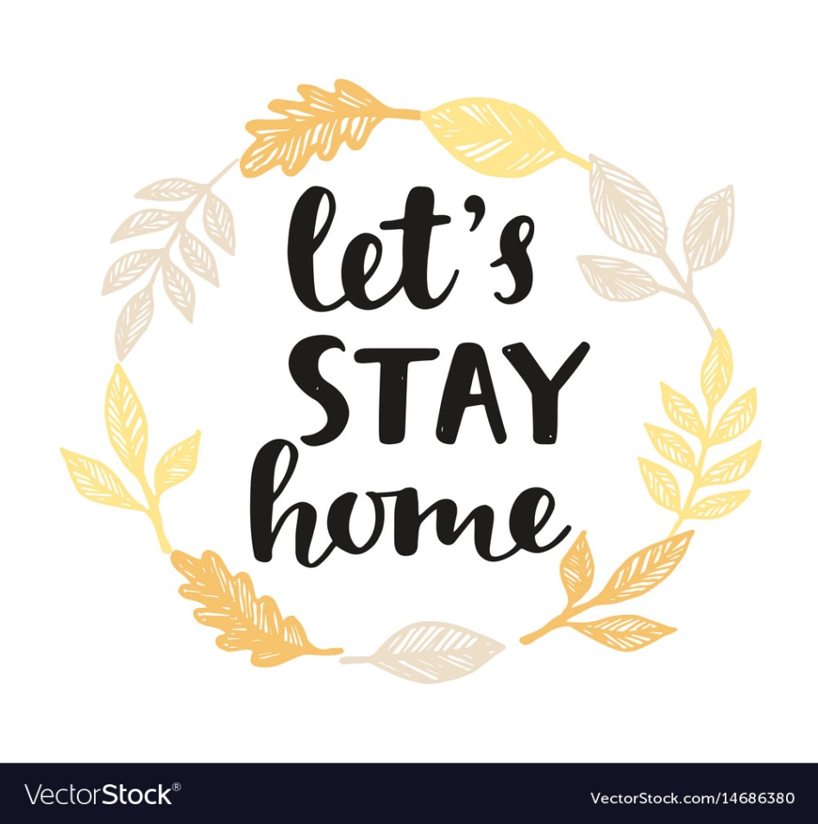
VALIA

